Module 5: Introduction to Ecological Forecasting - Student Handout



### Name: Piper Zimmerman

### Student ID: poz3615

#### Completed on: January 16, 2024

#### Copy-paste your save progress link from the Shiny app here for ease of reference: <https://macrosystemseddie.shinyapps.io/module5/?_inputs_&maintab=%22mtab6%22&tabseries1=%22obj5%22&run_mod_ic=10&run_mod_parm=11&run_mod_ann=26&submit_ques=0&load_fc=1&run_qaqc1=1&add_lm2=1&run_qaqc2=2&add_lm3=1&conv_fc=1&load_fc2=1&run_fc2=1&assess_fc3=1&update_fc2=2&assess_fc4=1&load_fc3=2&run_fc3=2&row_num=%224%22&phy_ic=10&parm_mort_rate=0.57&phy_init=9.42&mort_rate=1&nut_uptake=0.06&phy_init2=3.03&mort_rate2=0.88&nut_uptake2=0.07000000000000001&phy_init4=2.2&add_obs_ic=false&add_obs_parm=false&add_obs=true&add_newobs=true&members2=30&table01_rows_selected=4&_values_&sel_row=4>

# Macrosystems EDDIE Module 5: Introduction to Ecological Forecasting

# Learning Objectives:

By the end of this module, you will be able to:

* Describe an ecological forecast and the iterative forecasting cycle
* Explore and visualize NEON data using an R Shiny interface
* Construct an ecological model to generate forecasts of ecosystem primary productivity with uncertainty
* Adjust model parameters and inputs to study how they affect forecasts relative to observations
* Compare productivity forecasts among NEON sites in different regions

# Why macrosystems ecology and ecological forecasting?

**Macrosystems ecology** is the study of ecological dynamics at multiple interacting spatial and temporal scales (e.g., Heffernan et al. 2014). For example, *global* climate change can interact with *local* land-use activities to control how an ecosystem changes over the next decades. Macrosystems ecology recently emerged as a new sub-discipline of ecology to study ecosystems and ecological communities around the globe that are changing at an unprecedented rate because of human activities (IPCC 2013). The responses of ecosystems and communities are complex, non-linear, and driven by feedbacks across local, regional, and global scales (Heffernan et al. 2014). These characteristics necessitate novel approaches for making predictions about how systems may change to improve both our understanding of ecological phenomena as well as inform resource management.

**Forecasting** is a tool that can be used for understanding and predicting macrosystems dynamics. To anticipate and prepare for increased variability in populations, communities, and ecosystems, there is a pressing need to know the future state of ecological systems across space and time (Dietze et al. 2018). Ecological forecasting is an emerging approach which provides an estimate of the future state of an ecological system with uncertainty, allowing society to prepare for changes in important ecosystem services. Ecological forecasts are a powerful test of the scientific method because ecologists make a hypothesis of how an ecological system works; embed their hypothesis in a model; use the model to make a forecast of future conditions; and then when observations become available, assess the accuracy of their forecast, which indicates if their hypothesis is supported or needs to be updated. Forecasts that are effectively communicated to the public and managers will be most useful for aiding decision-making. Consequently, macrosystems ecologists are increasingly using ecological forecasts to predict how ecosystems are changing over space and time (Dietze and Lynch 2019).  
  
In this module, students will apply the iterative forecasting cycle to develop an ecological forecast for a National Ecological Observation Network (NEON) site of their choice. This module will introduce students to the basic components of an ecological forecast; how a forecasting model is constructed; how changes to model inputs affect forecast uncertainty; and how productivity forecasts vary across ecoclimatic domains.

## Module overview:

* Introduction to Ecological Forecasting: pre-readings and PowerPoint in class
* Activity A: Visualize data from a selected NEON site and build an ecological model
* Activity B: Generate a forecast and work through each stage of the iterative forecast cycle
* Activity C: Apply a forecast to a different NEON site and compare forecasts among sites

## Today’s focal question: *What is an Ecological Forecast?*

To address this question, we will introduce ecological forecasts and the iterative forecasting cycle. We will build a model that forecasts aquatic ecosystem productivity in response to multiple environmental factors (e.g., weather, herbivory). We will also examine the uncertainty associated with our forecast predictions, which can originate from multiple sources. In this module, we will use our productivity model to examine how forecast uncertainty is related to driver data, model parameters, and initial conditions. We will then compare productivity forecasts for ecosystems in different ecoclimatic regions to understand how forecasts can vary both over time and space.

We will be using ecological data collected by the National Ecological Observation Network (NEON) to tackle this question. NEON is a continental-scale observatory designed to collect publicly-available, long-term ecological data to monitor changing ecosystems across the U.S. Primary productivity in lakes is our focal forecast variable as it governs the biological activity of a lake and is a key indicator of ecosystem health that can change rapidly in response to environmental drivers.

Primary productivity is the process by which photosynthetic organisms (e.g., algae) make their own food from inorganic sources. These organisms use CO2 and solar energy to produce the food they need for their metabolism. Measurement of chlorophyll-a, a photosynthetic pigment, is a common proxy for quantifying aquatic primary productivity.

As the bottom-most trophic level in freshwater ecosystems, primary producers serve an essential role in providing nutrients and energy to higher trophic levels and higher organisms. For instance, zooplankton and fish need to graze on algae in a lake, so a baseline level of algae is needed to support their populations. Low primary productivity may thus hinder the growth of these other organisms by limiting available nutrients and energy. Conversely, extremely high primary productivity may result in algal blooms, which can have detrimental effects on zooplankton and fish because of their scums and toxins. Altogether, an intermediate level of primary productivity may support the most diverse and largest amount of biomass, with some variability across different lakes.

## R Shiny App:

The lesson content is hosted on an R Shiny App at <https://macrosystemseddie.shinyapps.io/module5/>  
This can be accessed via any internet browser and allows you to navigate through the lesson via this app. You will fill in the questions below on this handout as you complete the lesson activities.

## Optional pre-class readings and videos:

Webpages:

* [NOAA Ecological Forecasts](https://oceanservice.noaa.gov/ecoforecasting/noaa.html#:~:text=What%20is%20ecological%20forecasting%3F,%2C%20pollution%2C%20or%20habitat%20change.)
* [Ecological Forecasting Initiative](https://ecoforecast.org/about/)

Articles:

* Dietze, M. and Lynch, H. 2019. Forecasting a bright future for ecology. *Frontiers in Ecology and the Environment*, *17*(1), 3. <https://doi.org/10.1002/fee.1994>
* Dietze, M.C., et al. 2018. Iterative near-term ecological forecasting: Needs, opportunities, and challenges. Proceedings of the National Academy of Sciences, 115(7), 1424–1432. <https://doi.org/10.1073/pnas.1710231115>
* Jackson, L.J., Trebitz, A.S., & Cottingham, K.L. 2000. An introduction to the practice of ecological modeling. BioScience, 50(8), 694. [https://doi.org/10.1641/0006-3568(2000)050[0694:aittpo]2.0.co;2](https://doi.org/10.1641/0006-3568(2000)050%5B0694:aittpo%5D2.0.co;2)

Videos:

* NEON's [Ecological Forecast: The Science of Predicting Ecosystems](https://www.youtube.com/watch?v=Lgi_e7N-C8E&t=196s&pbjreload=101)
* Fundamentals of Ecological Forecasting Series: [Why Forecast?](https://www.youtube.com/watch?v=kq0DTcotpA0&list=PLLWiknuNGd50Lc3rft4kFPc_oxAhiQ-6s&index=1)

## Pre-class activity: Explore ecological forecasts

Examples of ecological forecasts:

* [USA-NPN Pheno Forecast](https://www.usanpn.org/data/forecasts/) - The USA National Phenological Network (NPN) Pheno Forecast delivers short-term (6 day) threshold-based forecasts of phenological events in plants and pest insects.
* [Smart & Connected Water Systems](https://smartreservoir.org/forecasts/) - A project which is developing a smart water system that integrates novel high-frequency sensors, cyberinfrastructure, and ecosystem forecasting techniques to improve the management of drinking water supply lakes and reservoirs.
* [EcoCast](https://coastwatch.pfeg.noaa.gov/ecocast/map_product.html) - EcoCast is a fisheries sustainability tool that helps fishers and managers evaluate how to allocate fishing effort to optimize the sustainable harvest of target fish while minimizing bycatch of protected or threatened animals.
* [Atlantic Sturgeon Risk of Encounter](http://robots.ceoe.udel.edu/shiny/sturgeon/) - This forecast is developed for mature Atlantic Sturgeon using historic telemetry observations matched to date, bathymetry, and sea surface temperature and ocean color from NASA’s MODIS AQUA satellite.
* [Grassland Production Forecast](https://grasscast.unl.edu/) - Grass-Cast uses almost 40 years of historical data on weather and vegetation growth - combined with seasonal precipitation forecasts - to predict if rangelands are likely to produce above-normal, near-normal, or below-normal amounts of vegetation.
* [Portal Project - Rodent Abundances](https://portal.naturecast.org) - Forecasting a time series of rodent abundances from The Portal project. A long-term ecological study in desert ecology located near Portal, AZ, USA.

#### Pre-class questions: Choose one of the ecological forecasts above and use the website to answer the questions below.

A. Which ecological forecast did you select?

**Answer: Atlantic Sturgeon Risk of Encounter**

B. What ecological variable(s) are being forecasted?

**Answer: Risk of encountering an Atlantic Sturgeon in five regions**

C. How can this forecast help the public and/or managers?

**Answer: If the risk is high, boating rules could be made in order to protect them**

D. Describe the way(s) in which the forecast is visualized.

**Answer: There is a map of the areas for the date, one day forecast, two day forecast, and three day forecasts. The area is green for low risk, yellow for medium, and red for high.**

Now navigate to the [Shiny interface](https://macrosystemseddie.shinyapps.io/module5) to answer the rest of the questions.

The questions you must answer are written both in the Shiny interface as well as in this handout. As you go, you should fill out your answers in this document.

# Think about it!

Answer the following questions:

1. How have you used forecasts (ecological, political, sports, any kind!) before in your day-to-day life?

**Answer: I check the weather/temperature forecast every day. I have looked at the win probability often during sporting events like the World Cup.**

1. How can ecological forecasts improve both natural resource management and ecological understanding?

**Answer: If we understand what resources are available, we can work to use less of or more of them in order to let some populations recover if needed. It can also help us with ecological understanding by using things like population forecasting, so we can understand the dynamics in the ecosystem.**

# Activity A: Get Data & Build Model

## Objective 1: Select and view site

Select a NEON site from the table, then click on the “View latest photo” button to load the latest image from that site. Follow the link at the bottom of the ‘About Site’ section to find out more about the site.

1. Fill out information about your selected NEON site:

*Table 1. Site Characteristics*

| Characteristic | Answer |
| --- | --- |
| Name of selected site | Little Rock Lake |
| Four letter site identifier | LIRO |
| Latitude | 45.998269 |
| Longitude | -89.704767 |
| Lake area (km2) | 0.16 |
| Elevation (m) | 501 |

## Objective 2: Explore data

Explore the data measured at the selected site. These are data that has been downloaded from the NEON Data Portal. The variables shown have been selected for this module but there are a wide range of variables collected at each NEON site.

1. Fill out the table in your Word document with the description of site variables:

*Table 2. Description of site variables:*

| Variable | Mean | Minimum | Maximum |
| --- | --- | --- | --- |
| Air temperature | 4.461 | -29.730 | 27.610 |
| Surface water temperature | 19.856 | 5.828 | 28.750 |
| Nitrogen | 0.07440 | 0.00000 | 0.23860 |
| Underwater PAR | 60.1306 | -9.1100 | 325.7000 |
| Chlorophyll-a | 3.9013 | 0.7049 | 23.4800 |

## Objective 3: Explore variable relationships

We will use chlorophyll-a sensor data to estimate primary productivity. Chlorophyll-a concentrations are an indicator of phytoplankton abundance and biomass. Explore the options below to see if there are any relationships between chlorophyll-a and the other variables measured at your site. This information will be used to build your model.

1. Describe the effect of each of the following variables on chlorophyll-a. Chlorophyll-a (chl-a) is used as a proxy measurement for phytoplankton concentration and primary productivity in aquatic environments. For each variable, write in the table whether increases in that variable are associated with increases in chl-a (positive relationship), decreases in chl-a (negative relationship), or no change in chl-a (no relationship).

*Table 3. Description of effect of each variable on chlorophyll-a*

| Variable | Relationship |
| --- | --- |
| Air temperature | Positive relationship |
| Surface water temperature | No relationship |
| Nitrogen | No relationship |
| Underwater PAR | Negative relationship |

## Objective 4: Understand model

Using your understanding of aquatic ecosystems, you will build a simple ecological model to predict primary productivity.

1. Describe the relationship between each of these driving variables and productivity according to the ecosystem model we are using today (depicted above). For example, if the driving variable increases, will it cause productivity to increase (positive), decrease (negative), or have no effect (stay the same).  
   1. Surface water temperature: There was no relationship. If surface water increases, it has no effect on productivity.
   2. Incoming light: There was a negative relationship. If incoming light increases, it decreases productivity.
2. Classify the following as either a state variable or a parameter by dragging it into the corresponding bin. Once you have checked your answers, record the correct answers in the final report.

*Table 4. Sorted parameters and state variables.*

| States | Parameters |
| --- | --- |
| Nitrogen | Maximum growth rate |
| Phytoplankton | Mortality rate |

1. We are using chlorophyll-a as a proxy of aquatic primary productivity. In your final report, describe how you envision each parameter to affect chlorophyll-a concentrations. For example, if the parameter increases, will it cause productivity to increase (positive), decrease (negative), or have no effect (stay the same)?  
   1. Maximum growth rate: I think the larger the growth rate is, the more productivity there will be (positive relationship).
   2. Phytoplankton mortality rate: I think the larger the mortality rate is, the less productivity there will be (negative relationship).

## Objective 5: Build model

Test different scenarios with your model to understand how it will respond under different environmental conditions. Use observed data to calibrate the model (i.e. make your model better match observed data).

1. Describe the effect of changing phytoplankton initial conditions on your model run. As you increase or decrease initial conditions, how does this affect modeled primary productivity?  
     
   **Answer: As I increase phytoplankton, the model becomes less smooth, and more peaked. There is the same generic shape, but more day to day change, and a slightly higher concentration of chlorophyll-a.**
2. Describe the effect of changing the phytoplankton mortality parameter on your model run. As you increase or decrease mortality, how does this affect modeled primary productivity?  
   **Answer: If the mortality rate is 0, the model reaches its max capacity pretty quickly. A very low death rate gives very high values for productivity, while a higher death rate gives lower values. The general shape is the same throughout (except for 0).**
3. Copy-paste the plot you downloaded that shows your calibrated model run into your final report by clicking ‘Save plot’.  
   **Answer:**  
     
   *Please copy-paste your Q-11-plot.png image here.*  
   A graph with red dots

   Description automatically generated  
   *Figure 1. Modeled primary productivity for your selected NEON lake compared to chlorophyll-a concentrations, a proxy measurement for aquatic primary productivity.*
4. Referring to the plot that shows your calibrated model, describe in your own words how well the model fits the data.

**The model does not do a great job of fitting the data. It does a decent job from May to June, but that is it. It doesn’t capture the clear pattern from July to October. It follows the generic positive trend in June, but not well.**

1. Record the model settings of your best-fit calibrated model in the Q13 table in your Word document.

*Table 5. Calibrated primary productivity model settings.*

|  | Phytos | Mortality | Uptake |
| --- | --- | --- | --- |
| Calibrated model settings | 9.43 | 1 | 0.06 |

# Activity B: Forecast!

## Objective 6: Examine uncertainty

Gain an understanding of what uncertainty is in the context of an ecological forecast and explore weather forecast data. Demonstrate how uncertainty can be quantified.

1. What is forecast uncertainty? How is forecast uncertainty quantified?  
     
   **Answer: Forecast uncertainty is the range of possible alternate future conditions predicted by a model. It can be quantified using ensemble modelling.**
2. Inspect the weather forecast data for the site you have chosen:  
   1. How does increasing the number of ensemble members in the weather forecast affect your understanding of the magnitude of uncertainty in future weather?  
        
      **Answer: When adding ensemble members, it is easier to see how the predictions are changing. In the distribution plot, you can see the bounds changing and getting wider as new ensembles are added that aren’t as close to the others.**
   2. Compare the air temperature forecasts for the first week (Sep 25 - Oct 1) to the second week (Oct 2 - 8). How does the forecast uncertainty change between the two periods?  
        
      **Answer: The uncertainty in the first week is much less than that in the second week. In the line plot, the ensemble members are much closer than the second week. In the distribution plot, the bounds are much more narrow.**
   3. Use the ‘Save plot’ button to save the NOAA forecast plot and copy-paste it into your final report.  
        
      **Answer:**

*Please copy-paste your Q-15-plot.png image here.*  
*Figure 2. Weather forecast plot at the selected NEON lake generated from National Oceanic and Atmospheric Administration (NOAA)* [*Global Ensemble Forecast System*](https://www.ncdc.noaa.gov/data-access/model-data/model-datasets/global-ensemble-forecast-system-gefs) *(GEFS).*

## Objective 7: Prepare inputs

Using observed data from your lake site, you will build a linear model to convert air temperature to surface water temperature and shortwave radiation (SWR) to underwater photosynthetic active radiation (uPAR), which are the inputs required for your primary productivity model.

1. Explain, in your own words, why it is necessary to convert the NOAA forecasts of air temperature and shortwave radiation into forecasts of water temperature and underwater PAR as a step towards generating forecasts of primary productivity.  
     
   **Answer: Our driver variables are water temperature and underwater PAR. NOAA does not provide these, so we need to get them ourselves.**

## Objective 8: Forecast

Use forecasted water temperature and uPAR and up-to-date initial conditions to drive your calibrated model into the future and forecast primary productivity.

1. Use the ‘Save plot’ button to save the plot of your forecast and copy-paste it into your final report.  
     
   **Answer:**  
     
   *Please copy-paste your Q-17-plot.png image here.*

*Figure 3. Ecological forecast for primary productivity at your selected NEON lake for the next 30 days.*

1. Examine the plot depicting your forecast.  
     
   1. Under ‘Load Driver Forecasts’, remove the effect of driver uncertainty on your forecast by adjusting the number of ensemble members to 1, and re-run your forecast. Then, adjust the number of ensemble members to 30 and re-run the forecast. How does including driver uncertainty affect the forecast?  
        
      **Answer: As we forecast further into the future, adding more ensembles widens the uncertainty.**
   2. How does altering the initial condition of your forecast affect forecast output?  
        
      **Answer: The higher the initial condition is, the higher the original forecast is. It then slopes downward, quickly with higher initial condition, until it levels out. A low initial condition starts the forecast below the observed values, and puts it on an upward trend.**

## Objective 9: Communicate forecast

Forecasts that are effectively communicated to the public and managers will be most useful for aiding decision-making. Here you will think about how to communicate your forecast to an end-user.

1. How would you communicate your forecast of primary productivity at your NEON site so it could be understood by a fellow classmate?  
     
   **Answer: The primary productivity increases slightly to around 3 with the first forecast, then over the next few days decreases and begins to level out around 2.**
2. Examine the example forecast visualizations below.  
     
   1. Which of these four visualizations do you think most effectively communicates your forecast, and why?  
        
      **Answer: I think the fourth visualization with the forecasted values, the median, and the 95% interval is the best. It shows the actual forecast but also shows the uncertainty around it, compared to the others only showing the forecast or the uncertainty.**
   2. Download and copy-paste the visualization that you think best communicates your forecast into your final report.  
        
      **Answer:**  
        
      *Please copy-paste your Q-20-visualization.png image here.*  
      A green line graph with white text

      Description automatically generated  
      *Figure 4. A visualization of an ecological forecast for primary productivity at your selected NEON lake for the next 30 days. You selected this visualization to optimize forecast communication.*

## Objective 10: Assess forecast

A fundamental part of the forecast cycle is assessing how well your forecast performed relative to observations. Here we will use a simple assessment of plotting forecast results against observations.

1. Examine the predicted vs. observed plot as well as the value of R2.  
     
   1. How well did your forecast do compared to observations?  
        
      **Answer: My forecast did okay. It captured the first couple observations, but then the true observations begin to decrease MUCH faster than my forecast.**
   2. Download and copy-paste the forecasted vs. observed plot into your final report.  
        
      **Answer:**  
        
      *Please copy-paste your Q-21-plot.png image here.*  
      A graph of a graph

      Description automatically generated with medium confidence  
      *Figure 5. Assessment of the forecast one week later by comparing the forecast to new observations at your selected NEON lake.*

# Activity C: Complete the forecast cycle

## Objective 11: Update model

Update our model to improve our forecasts based on the recent observations that have been collected.

1. Complete the following steps to document your forecast updating process.  
     
   1. Record your original and updated model settings in the Q22 table in your final report.  
        
      **Answer:**  
      *Table 6. Calibrated and updated primary productivity model settings.*

|  | Phytos | Mortality | Uptake |
| --- | --- | --- | --- |
| Calibrated | 9.42 | 1 | 0.06 |
| Updated | 3.03 | 0.88 | 0.07 |

* 1. Download and copy-paste your updated forecast plot into your final report.  
       
     **Answer:**

*Please copy-paste your Q-22b-plot.png image here.*  
*Figure 6. Updated forecast by updating the model parameters for your selected NEON lake site.*

* 1. Download and copy-paste the plot assessing your updated forecast into your final report.  
       
     **Answer:**  
       
     *Please copy-paste your Q-22c-plot.png image here.*  
     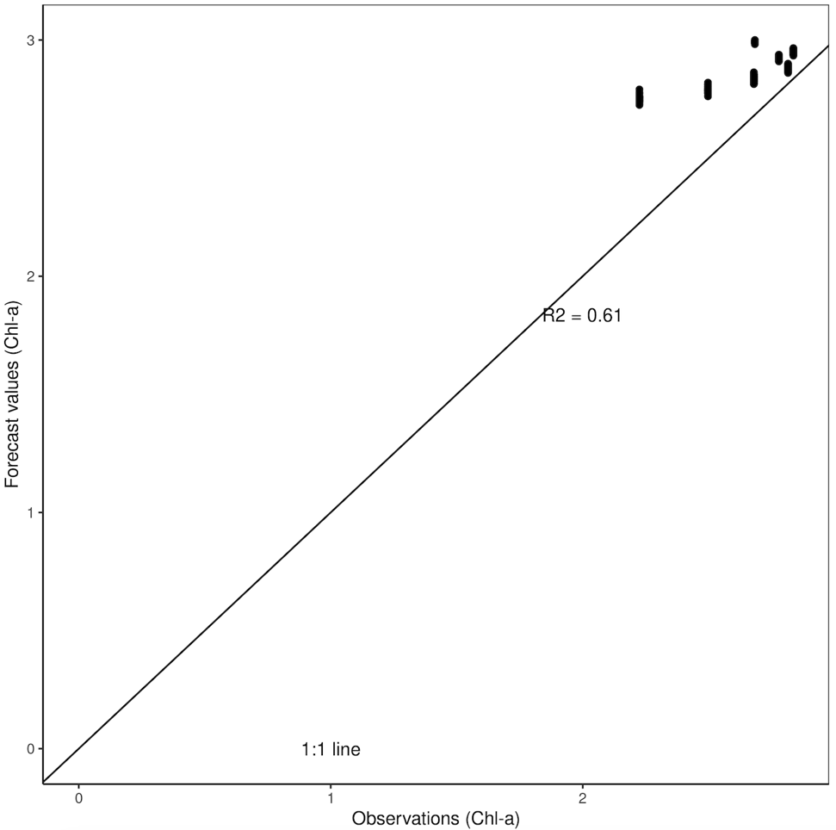  
     *Figure 7. Assessment of the updated forecast.*
  2. Were you able to successfully improve your forecast by updating your model parameters? Explain what you did and how you know whether your forecast has improved.  
       
     **Answer: Yes, I was able to improve my forecast. I can tell because my R squared is slightly higher with my updated parameters. If the forecasts were exact, the R squared would be one, so we are looking to get the largest R squared possible.**

## Objective 12: Next forecast

The forecast cycle is an iterative process. Now after communicating and assessing our forecast and updating our model parameters, we will update our driver forecasts and initial conditions to generate the next forecast.

1. Document and describe the new forecast of primary productivity.  
     
   1. Record all your model settings in the Q23 table in your final report.  
        
      **Answer:**  
      *Table 7. Primary productivity model settings for the first forecast, updated forecast, and second forecast.*

|  | Phytos | Mortality | Uptake |
| --- | --- | --- | --- |
| Forecast 1 | 9.42 | 1 | 0.06 |
| Updated Forecast | 3.03 | 0.88 | 0.07 |
| Forecast 2 | 2.2 | 0.88 | 0.07 |

* 1. Download and copy-paste the plot of your second forecast into your final report.  
       
     **Answer:**  
       
     *Please copy-paste your Q-23-plot.png image here.*  
     A graph of a line graph

     Description automatically generated with medium confidence
  2. Describe the new forecast of primary productivity.  
       
     **Answer: My new forecast starts around 2.2 and has a very slight negative trend.**

1. Why is the forecast cycle described as ‘iterative’ (i.e. repetition of a process)?  
     
   **Answer: The forecast cycle in considered iterative because you are constantly changing the parameters of your model when there is new information. For example, once we got a week of new data, we went back and changed the model parameters to better fit the trend of the current data.**

This module was developed by Moore, T.N., M.E. Lofton, C.C. Carey, and R.Q. Thomas. 03 July 2023. Macrosystems EDDIE: Introduction to Ecological Forecasting. Macrosystems EDDIE Module 5, Version 2. <http://module5.macrosystemseddie.org>. Module development was supported by NSF grants DEB-1926050 and DBI-1933016.

This document last modified: 03 July 2023 by MEL.